A Wavelet Entropy Approach for Detecting Lightning Faults on Transmssion Lines

Ahmad Abdullah

Texas A&M University

Department of Electrical and Computer Engineering

College Station, TX, 77840

E-mail: ahmad@tamu.edu

*Abstract*—Many authors proposed methods to classify transients on transmission lines. However, all of these methods fail when a lightning strike evolves to a fault. In this paper we propose a new method that can be used to detect whether a lightning strike evolves to a fault or not. The mechanism for lightning strike evolving to a fault is first reviewed. Clarke Transformation is used to transform phase currents into 0-α-β components. The α-component is then normalized. Discrete Wavelet Transform (DWT) is used afterwards to extract the coefficients of approximation_5 of the α-component. A window of one half of a cycle of post lighting data is then taken to calculate the entropy of the aerial current at that window by summing up the squares of the coefficients extracted. This energy (entropy) is compared against a preselected threshold. If the energy calculated is higher than this threshold then the strike is evolving to a fault. Numerous simulations have been done using ATP/EMTP to verify the validly of the method proposed.

Keywords— ATP, EMTP, Faults, Lightning, Discrete Wavelet Transform, Arc

# Introduction

For a very long time, power engineers used to have difficulty quantify outages and damage to their system arising from lightning strikes ‎[1]. Many attempts have been carried out in literature to assess such outages and damage. The first step usually involves using the isokeraunic charts ‎[2] to calculate the Ground Flash rate ‎[3]. A more accurate approach is to use flash density maps ‎[4] to calculate approximate number of lightning days at a certain location. The main problem with these approaches is that they are very regional ‎[3]‎[5]. Moreover, knowing this number gives no assertion of whatsoever that a lightning strike will cause a fault on the line. Thus the authors in ‎[1] motivated by those limitations have proposed a low cost instrumentation method that can make such discrimination.

On the other hand, many authors in literature notably in ‎[6] and ‎[7] have proposed methods for transient classification on transmission line using neural network methods. Transient classification is mainly done as a means of fault detection where fault is just a type of disturbances to be recognized. Those methods fail completely if one transient event evolves to another which is very evident when a lighting surge causes fault on a line. In this paper we aim to augment those classification algorithms by an intuitive method that can detect lightning faults.

Detection of lighting faults using wavelets related methods has been given in ‎[8] and ‎[9]. A major drawback of these approaches is threshold selection since they relate different details coefficients in different wavelets levels to each other which is hard to tune in practice.

Many publications have dealt with the process of a lighting strike evolving to a fault ‎[10]‎[11]‎[12] (mainly flashover of insulators) or even a back flashover ‎[13]‎[14]. The process is summarized with major simplifications as follows:

1. A lightning strike either hits the phase or ground wire
2. The voltage of the insulator rises rapidly with respect to ground due to that strike.
3. A statistical time lag (in the range of microseconds) is passed before the voltage peak of the insulator attains the high voltage peak of the strike. This basically means that the peak of the insulator voltage lags the peak of the lightning strike.
4. In any case, this time lag is small and when the voltage reaches a certain value, a flashover occurs which manifests itself as an arc from the insulator on the tower to ground.

We are not interested in the process that happens after this point which might lead to the extinction of the arc and/or a back flashover. The detailed process of this evolution does not concern us as will be explained in the methodology below.

The use of wavelet entropy methods for classification has been first proposed in ‎[15]. In this paper, we propose a new method for detection of lightning faults without using any special measurement methods as given in ‎[1]. Our method can be implemented as a simple software tool in a substation or SCADA to detect lighting faults. The paper is organized as follows: methodology is given in section II; simulation platform is presented in section III; results are provided in section IV, while conclusions are provided at the end of the paper.

# Methodlogy

It should be apparent from the evolution process of lightning faults described above that the fundamental frequency current increase in magnitude as the fault occurs while the magnitude of the fundamental frequency doesn’t increase if the lightning strike doesn’t evolve to a fault. It doesn’t matter whether the arc is initiated from the insulator to ground, conductor to ground or conductor to conductor. Arc will be initiated and this causes the fundamental current to increase in magnitude. It should be clear as well that a fault following a lightning strike will occur within microseconds from the strike. This is because the statistical time lag and the travelling wave propagation time are very small. So if we take a window of one half of a cycle starting from the moment of lightning strike, a fault should be seen within such a window. The essence of the method is that when a lightning strike evolves to a fault, the 60 Hz current magnitude is increased but when the strike doesn’t evolve, the fundamental frequency doesn’t change. Calculating the area of the squared value of a derived signal from fundamental current and comparing it against a predetermined threshold should indicate whether a fault occurred or not.

A lighting strike could evolve to either a LG or LLG or a three phase fault, in any case we will need to determine which phase is faulted so as to apply our window to the phase faulted. Instead, we apply 0-α-β transformation (Clarke transformation) to the three phase currents and use the α-component (which is an aerial mode current) as the current that need to be analyzed. This way, we need to analyze one current not three currents. We then apply a window of one half of a cycle to α-component starting from the moment of lightning strike. A discussion on why the α-component is suitable for our analysis is given in ‎[16]. The most important reason is that α-component always has higher amplitude than the phase current. Such property make the selection of the threshold easier as it increases the area under study. We then normalize the α-component using the pre-lightning current fundamental peak value. Doing this, the pre-lightning maximum current value will equal to unity.

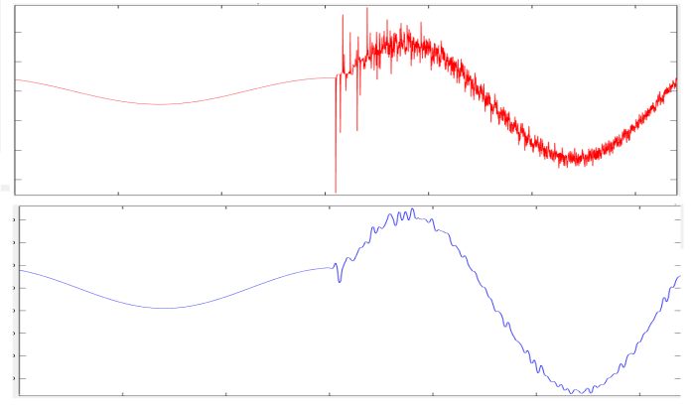

Fig. 1. Phase current of a certain lighting fault (upper plot) and approximation_5 of the same current (lower plot)

DWT is then applied to α-component to retrieve approximation_5. DWT applies low and high pass filter to the signal such that it produces level_1 and approximation_1 in the first iteration. Level_1 details correspond to high frequencies while approximation_1 details correspond to the lower frequencies. For example, if we have a signal that has a maximum frequency of 100 KHz, then the application of DWT at the first iteration produces level_1 corresponding to frequencies on the range of 100 kHz to 50 kHz while approximation_1 will correspond to signals from 50kHz to 0 Hz. If we apply DWT one more time, we get level_2 corresponding to signals occupying frequency ranges from 50 kHz to 25 kHz and approximation_2 corresponding to signals from 25kHz to 0Hz. In our analysis, we apply DWT till we get to approximation_5. This done mainly to get rid of the noise imposed on the signal as much as we could. When a lightning strikes a line, oscillations will be imposed on the fundamental. Applying DWT till we reach approximation_5 will eliminate most of these noises as shown in fig. 1.

We then calculate the integral of the squared normalized α-component which corresponds to the energy by summing up the squared coefficients of approximation_5. Since the current is assumed a sine wave, this integral should not increase beyond π/2 if there is no fault. If the strike evolves to a fault, then this integral will exceed π/2. The threshold should then be taken to equal π/2 but in reality it will be slightly higher than this because approximation_5 will have more noise due to the lighting oscillations as shown in fig. 1.

In Summary, the procedure is as follows:

1. Decouple the three phase currents using Clarke Components
2. Normalize the α-component using the pre-lighting value such that the maximum of the pre-lightning sine wave is 1. This basically means dividing the signal by the peak of the pre-lightning signal.
3. Extract approximation_5 of the α-component current for one half of a cycle of post lighting data
4. Sum the squares of details of approximation_5 coefficients to calculate entropy (energy)
5. If the energy exceeds a threshold, then the lighting strike has evolved to a fault.

The threshold is calculated using a set of predetermined lightning strike simulations with no fault evolving. We strike the line by lightning strikes with different amplitudes and at different line location and calculate the entropy as defined above. This threshold shouldn’t exceed π/2 by a large margin. However, it will be seen in simulations that when a strike becomes a fault, the entropy is higher than π/2. It should be noted that depending on the definition of the DWT used, this integral will be proportional to π/2. In our analysis, we selected DWT transformation equation such that it is an orthonormal transformation ‎‎[17]; that is it preserves areas. The equation of transformation and the equation for calculating the energy are shown in equations (1) and (2) respectively.

|  |  |
| --- | --- |
| $$W[f(t)]\left(a,b\right)=\frac{1}{\sqrt{a}}\int_{-∞}^{∞}{ψ\overline{(\frac{t-b}{a})×f\left(t\right)dt}}$$ Where f(t) is the signal, a is dyadic dilation and b is dyadic position. | (1) |

If we call the output of equation (1), $C_{a,b}$, then the energy at certain level (or approximation) is given by equation (2)

|  |  |
| --- | --- |
| $$Energy (Entropy)=\sum_{b=-∞}^{b=∞}{C_{a,b}^{2}}$$ | (2) |

A flow chart showing the methodology is shown in fig. 2.

It should be pointed out we have selected the window to be half a cycle for a reason. Consulting fig. 1 we see that the when a fault occurs almost around the peak of the current- a worst case scenario, it takes at least one quarter of a cycle for the current to reaches its new peak. Theoretically, and referring back to fig. 1, the current –being at positive peak- can continue to decrease and reach its new peak which will be negative after half a cycle. One half of a cycle is then the necessary window length to achieve a secure decision if it takes the current half a cycle to reach the new peak.



Fig. 2. Lighting fault detection flowchart.

# Simulation Platform

In this section we show how simulations have been carried out to test the methodology in part A. Application of algorithm is illustrated in section B. Lastly threshold determination is discussed in section C.

## EMTP Model

A line, shown in fig. 3, is modeled with frequency dependent parameters. We use IEEE 118 bus case ‎[18] with the area under study shown in fig. 4. The tower in fig. 3 is line 23-25 shown in fig. 4.

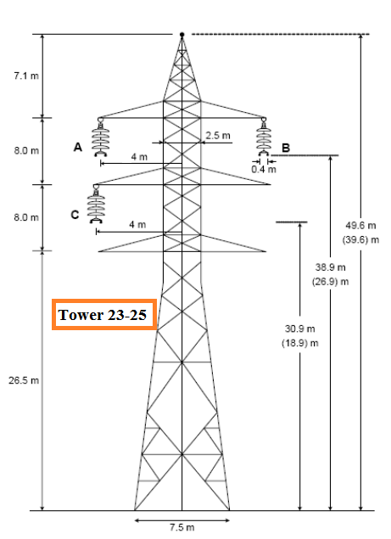

Fig. 3. Tower configuration of line 23-25

We strike the phase or the ground wire of this tower by a lightning strike. The lightning type used is an ATP Heidler type. This strike has a magnitude of 20 kA at 20%, 50% and 80% of the line length with a front duration of 4 microseconds and a τ of 10 microseconds. We then create a series of faults on the towers after 50 milliseconds. Referring to fig. 5, we keep the location of the lighting strike fixed for each of the three strike mentioned above while changing the location of the fault. The faults created are LG, LLG and LLLG faults. A total of 1044 lighting fault cases have been created spanning all fault types. The creation of fault cases has been automated using the toolbox released in ‎[19]. EMTP sampling time is 1µs. We then measure the current going from terminals 23 and 25. Since bus 25 is very close to a generator its current will increase materially which would be trivial to test with our methodology. For this we only apply our methodology to current at terminal 23 in which the fundamental current is expected to increase in a less noticeable way since no generator is feeding the fault from that end. We are not interested in creating a fault from the neutral wire to ground as our aim is to detect phase faults.

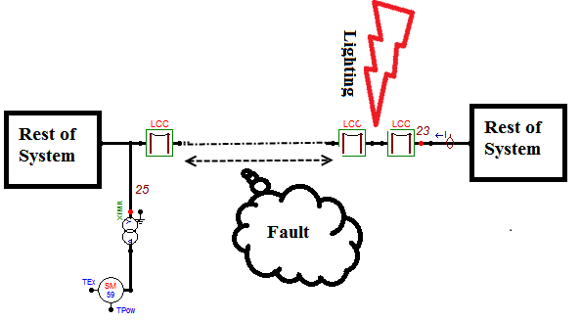

Fig. 5. Portion of the system under study

Arc is modeled with the data given in ‎[20]. As explained in the methodology, it is apparent that this simulation platform is adequate for our purposes i.e., there is no need to model the failure process of the insulator in deep details because we are only interested in the integral of the post-fault fundamental signal which, as will be seen shortly, is much larger than the integral of the same window with no fault.

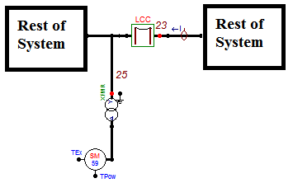

Fig. 4. Portion of the IEEE 118 system under study

All lines except the line under study are modeled with frequency dependent parameters with no ground wires.

## Application of the methodology

After ATP simulations are done, we have a script that converts Pl4 files- that contains phase currents- into mat files. Another script is called to convert the phase currents to Clarke currents, extract the α-component from newly created signals and then normalize it.

A window of one half of a cycle is then applied to the α-component once the lighting is detected.

DWT is applied afterwards to extract the coefficients of approximation_5. Those coefficients are then squared and summed. The summation is to be compared against the threshold. It should be noted that the integration in equation (2) is for infinite number of coefficients whereas in our case it is finite because we are summing the coefficients for the half cycle under study.

The only missing part that we haven’t talked about yet is threshold determination. This selection is discussed in the subsection C below.

## Threshold Selection

As explained in the methodology, when a lighting strike doesn’t evolve to a fault the integrated area under study should not exceed π/2. However due to the noise imposed on the signal because of the lighting, this area will not correspond exactly to π/2 but will be slightly higher. A threshold must be chosen such it has some safety margin against round off and measurement errors.

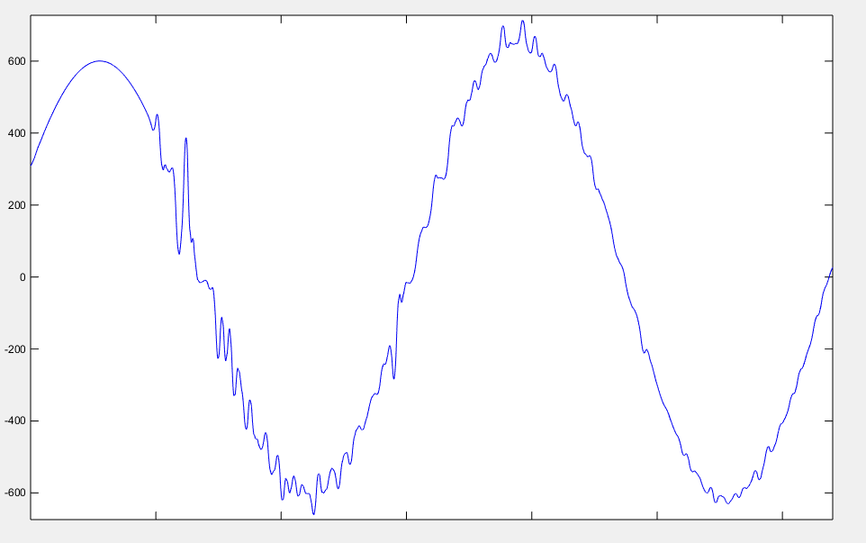

Fig. 6. Algorithm fails when the current doesn’t increase materially after lighting fault

To determine such a threshold, we run three EMTP simulations. Each simulation corresponds to a strike with 20 kA amplitude at 20%, 50% and 80% of the line length. These simulations are set-up such that the strike doesn’t cause a fault. We extract the α-component, normalize it and calculate the energy in one half of a cycle of approximation_5.

We found that the area doesn’t exceed 1.7 in all three cases so we select that as our threshold. If our calculations and methodology is correct, the area of the same one half of a cycle of the same aerial component of a lightning fault should exceed that by a good margin if the available short circuit level at the measurement is adequate. In the next section we discuss results.

# Results

As explained in section II, a total of 1044 of lighting fault cases have been generated. Application of our algorithm yields a total of 1029 correctly classified cases. The area integrated and compared against the threshold wasn’t less than 2 in all cases correctly classified.

A detailed study for the ones that have not been correctly classified has been undertaken. Fig. 6 has been inserted to better understand why the methodology proposed fails in some cases. The case shown in Fig. 6 is for a LL fault at 90% of line length away from terminal 23. As can be seen for the figure, the short circuit current is very small causing the algorithm proposed to fail.

# Conclusions

This paper has proposed an intuitive method to detect lighting faults within half of a cycle of the lighting strike. The method can be used to augment existing transient classification methods. Numerous simulations have been carried out to show the validity of the method. The threshold given in this paper should be used as universal guide for threshold selection for all other lines since the α-component is normalized. A disadvantage of the method is that it fails when the short circuit current is not high enough. Such a failure is expected since the area will be almost equal to the selected threshold. A way to rectify this issue is to use longer integration windows such as using one cycle of post-lighting data. By using such longer windows, the method can’t be used in a real time protection scheme along with transient classification algorithms. Another drawback of the method is that the method proposed cannot tell which phase is faulted. Determination of the faulted phase will, probably, require analyzing the three phase currents and is a subject for further research.

# References

1. Parrish, Dee E.; Kvaltine, D.J., "Lightning faults on distribution lines," Power Delivery, IEEE Transactions on , vol.4, no.4, pp.2179,2186, Oct 1989
2. Anderson, R. B., and Eriksson, A. J., “Lightning Parameters for Engineering Application”, Electra, no. 69, pp. 65-102, Mar. 1980
3. IEEE Guide for Direct Lightning Stroke Shielding of Substations," IEEE Std 998-1996 , vol., no., pp.i,163, 1996
4. Shui Ming Chen; Du, Y.; Ling Meng Fan, "Lightning data observed with lightning location system in Guang-Dong Province, China," Power Delivery, IEEE Transactions on , vol.19, no.3, pp.1148,1153, July 2004
5. Shindo, T.; Yokoyama, S., "Lightning occurrence data observed with lightning location systems in Japan: 1992-1995," Power Delivery, IEEE Transactions on , vol.13, no.4, pp.1468,1474, Oct 1998
6. Perera, N.; Rajapakse, A.D., "Recognition of Fault Transients Using a Probabilistic Neural-Network Classifier," *Power Delivery, IEEE Transactions on* , vol.26, no.1, pp.410,419, Jan. 2011
7. Silva, K.M.; Souza, B.A.; Brito, N.S.D., "Fault detection and classification in transmission lines based on wavelet transform and ANN," *Power Delivery, IEEE Transactions on* , vol.21, no.4, pp.2058,2063, Oct. 2006
8. Haifeng Li; Gang Wang; Zhiwei Liao, "Distinguish between lightning strikes and faults using wavelet-multi resolution signal decomposition," Developments in Power System Protection, 2004. Eighth IEE International Conference on , vol.1, no., pp.80,83 Vol.1, 5-8 April 2004
9. Guibin Zou; Houlei Gao; Ming Xu; Xin Wang; Tao Wang; Dapeng Wang, "Identification of Lightning Stroke and Fault in the Transient Component Based Protection," Power and Energy Engineering Conference, 2009. APPEEC 2009. Asia-Pacific , vol., no., pp.1,5, 27-31 March 2009
10. Okabe, S.; Tsuboi, T.; Takami, J., "Analysis of aspects of lightning strokes to large-sized transmission lines," Dielectrics and Electrical Insulation, IEEE Transactions on , vol.18, no.1, pp.182,191, February 2011
11. Motoyama, H., "Experimental study and analysis of breakdown characteristics of long air gaps with short tail lightning impulse," Power Delivery, IEEE Transactions on , vol.11, no.2, pp.972,979, Apr 1996
12. Xi Wang; Zhanqing Yu; Jinliang He, "Breakdown Process Experiments of 110- to 500-kV Insulator Strings Under Short Tail Lightning Impulse," Power Delivery, IEEE Transactions on , vol.29, no.5, pp.2394,2401, Oct. 2014
13. Inoue, A.; Kanao, S.-I., "Observation and analysis of multiple-phase grounding faults caused by lightning," Power Delivery, IEEE Transactions on , vol.11, no.1, pp.353,360, Jan 1996
14. Motoyama, H.; Shinjo, K.; Matsumoto, Y.; Itamoto, N., "Observation and analysis of multiphase back flashover on the Okushishiku Test Transmission Line caused by winter lightning," Power Delivery, IEEE Transactions on , vol.13, no.4, pp.1391,1398, Oct 1998
15. Gaouda, A.M.; Salama, M.M.A.; Sultan, M.R.; Chikhani, A.Y., "Application of multiresolution signal decomposition for monitoring short-duration variations in distribution systems," *Power Delivery, IEEE Transactions on*, vol.15, no.2, pp.478, 485, Apr 2000
16. Schweitzer, E.O.; Guzman, A.; Mynam, M.V.; Skendzic, V.; Kasztenny, B.; Marx, S., "Locating faults by the traveling waves they launch," Protective Relay Engineers, 2014 67th Annual Conference for , vol., no., pp.95,110, March 31 2014-April 3 2014
17. Albert Boggess, Francis J. Narcowich, A First Course in Wavelets with Fourier Analysis, College Station, TX: Wiley 2009, page 123
18. Power Systems Test Case Archive, [online] <https://www.ee.washington.edu/research/pstca/pf118/pg_tca118bus.htm>
19. Abdullah, A, “ATPMAT: An Open Source Toolbox for Systematic Creation of EMTP Cases in ATP Using Matlab,” proceedings of the 2015 North American Power Symposium (NAPS), Charlotte, NC, October 4-6 2015
20. Terzija, V.V.; Koglin, H.-J., "On the modeling of long arc in still air and arc resistance calculation," Power Delivery, IEEE Transactions on , vol.19, no.3, pp.1012,1017, July 2004